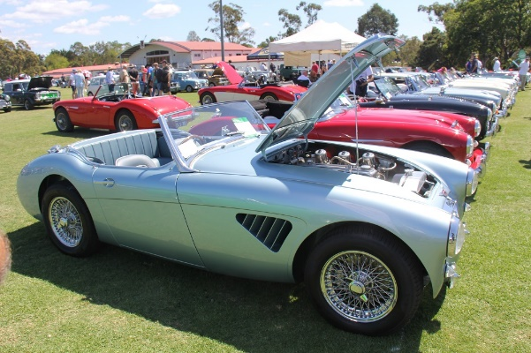
All British Day
Sunday 19th September 2021
One of the great highlights of our club year is on again folks.
All British day will kick off at St Joseph’s College Sports grounds, Vivian Street, Tennyson. 8:30am to 2 pm. (Gates open at 7.00am). Our All British Day is in its 41st year!
For our club the day will start with breakfast from 7 am at the popular Art and Gusto Restaurant at 5/409 Honour Avenue, Graceville, a short drive from the Tennyson venue.
If you wish to join us for breakfast, please let Paul Blake know and he will send you the breakfast menu. Please email Paul at brumby1009@gmail.com before Tuesday 14th September to let us know if you are joining us for breakfast.
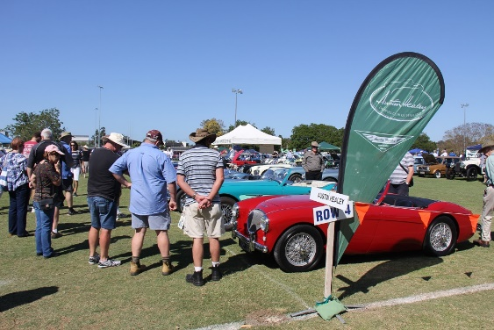
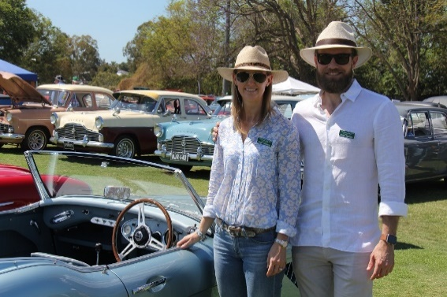
An early run in the Healey and breakfast is a great way to start the day and then at about 8am we will make our way to the event where the club marquee will provide shade and we can wander amongst the huge collection of British cars which are always on display at this event. Buy lunch at the event or bring along a picnic. Entry is $20 for a display car and passengers.

Don’t miss out book for breakfast now!

